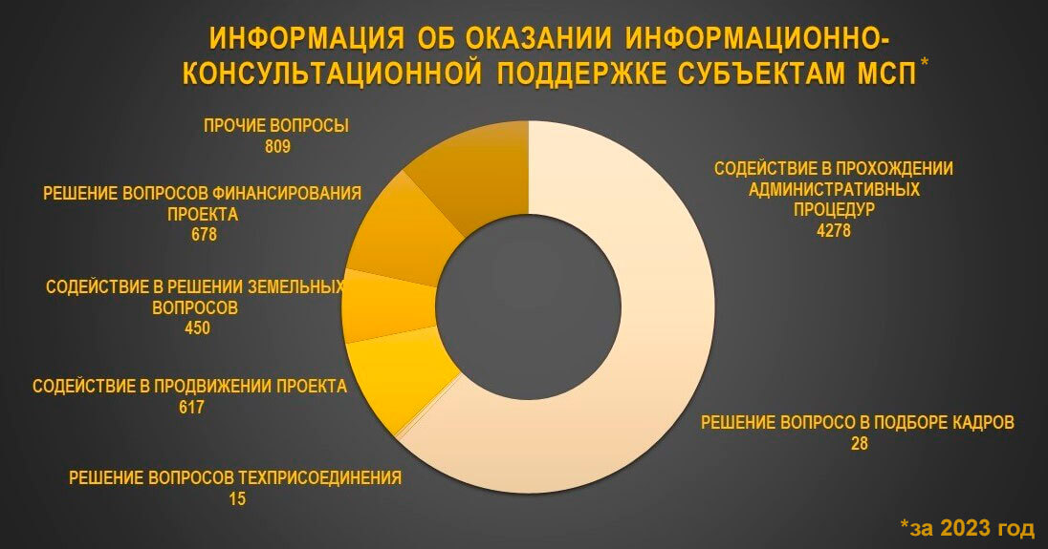

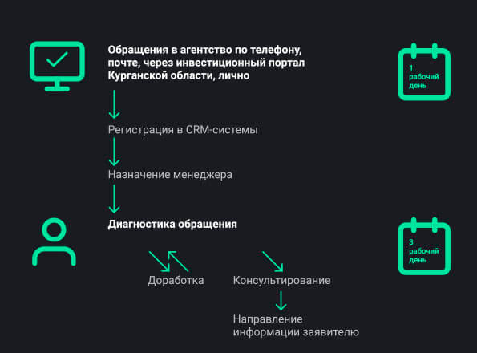

<https://мойбизнес45.рф/support-category/uslugi-ao-korporatsiya-msp/>

<https://мойбизнес45.рф/2024/06/18/ekspress-konsultatsiya-ot-tsentra-moj-biznes/>